
DHARMSINH DESAI UNIVERSITY, NADIAD
FACULTY OF MANAGEMENT AND INFORMATION SCIENCE
B.C.A. SEMESTER VI
SUBJECT: (25BCA601)SYSTEM DEVELOPMENT PROJECT

Student Name | Himanshu D Ladha
Roll No | BCA045
Student ID | 23BCUOS055

Project Definition: RestoFlow – A full-stack Restaurant Management Platform.

Company Timing: 11:00 AM to 6:00 PM

Week | Date | Day | Name of the Topic | Signature
Fourth Week | 22-12-2025 | Monday | CRUD operations – Admin and Added the UI
Fourth Week | 23-12-2025 | Tuesday | Forgot & restart password AND Meal Images
Fourth Week | 24-12-2025 | Wednesday | Added the footer and some changes.
Fourth Week | 25-12-2025 | Thursday | --holiday--
Fourth Week | 26-12-2025 | Friday | Added the customer footer

External Guide Name: Internal Guide Name: Prof. Rupal Patel
Signature Signature

22-12-2025
- In the Admin side – Added the functionality of Add, delete and Update the Restaurant. That can be only be managed by the Admin only.
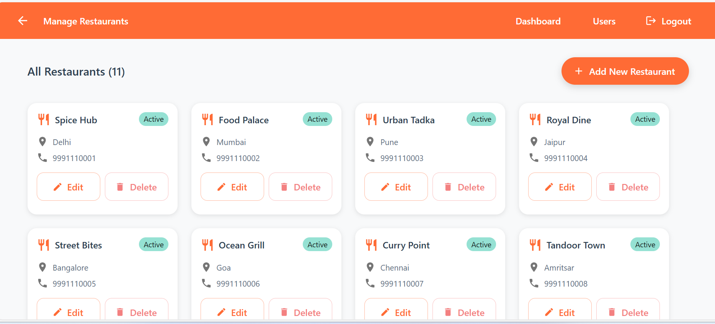

- Added the InBuilt UI for the project.

For Now, Added the Differently for Customer side and Admin & Restaurant Admin side.
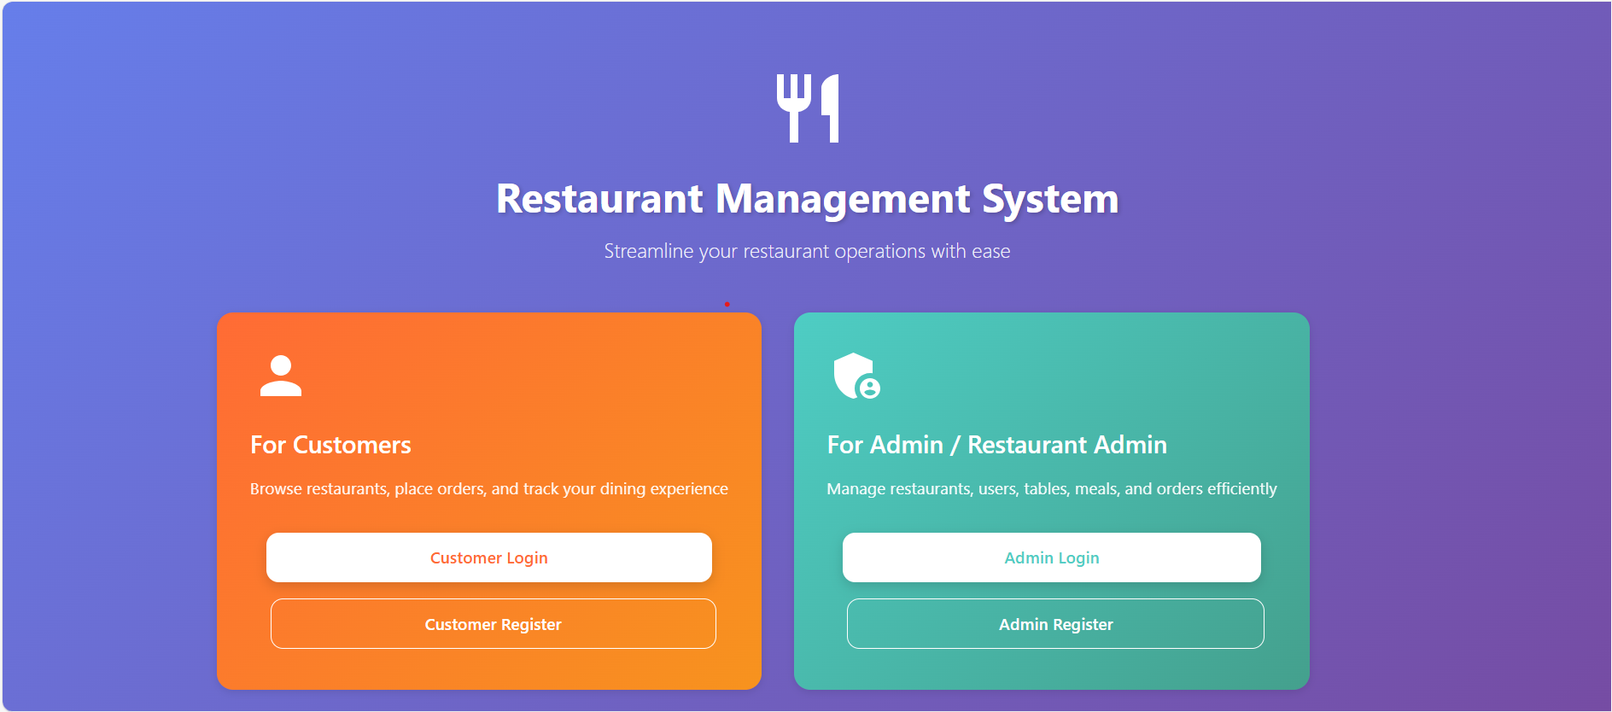
More images for the UI and some graphics for example only….
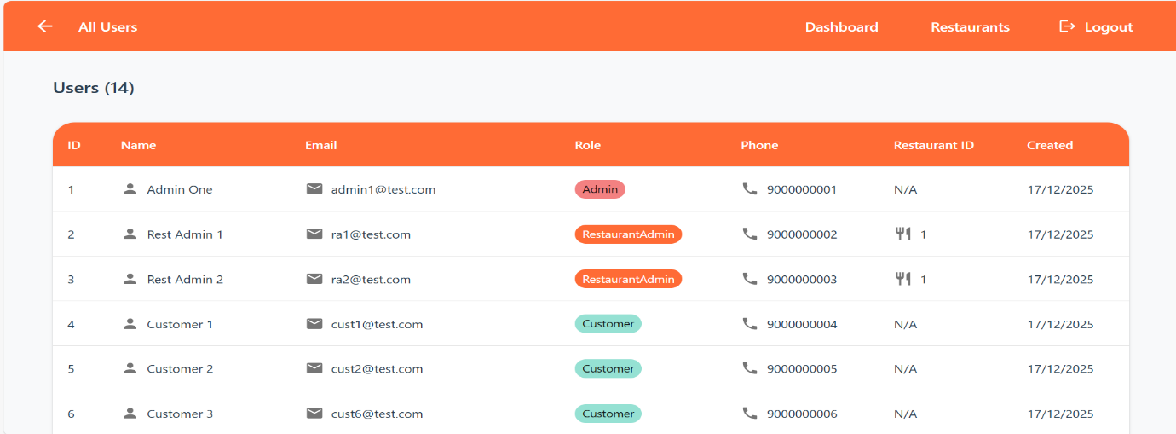
Restaurant Admin Side:-
Table:-
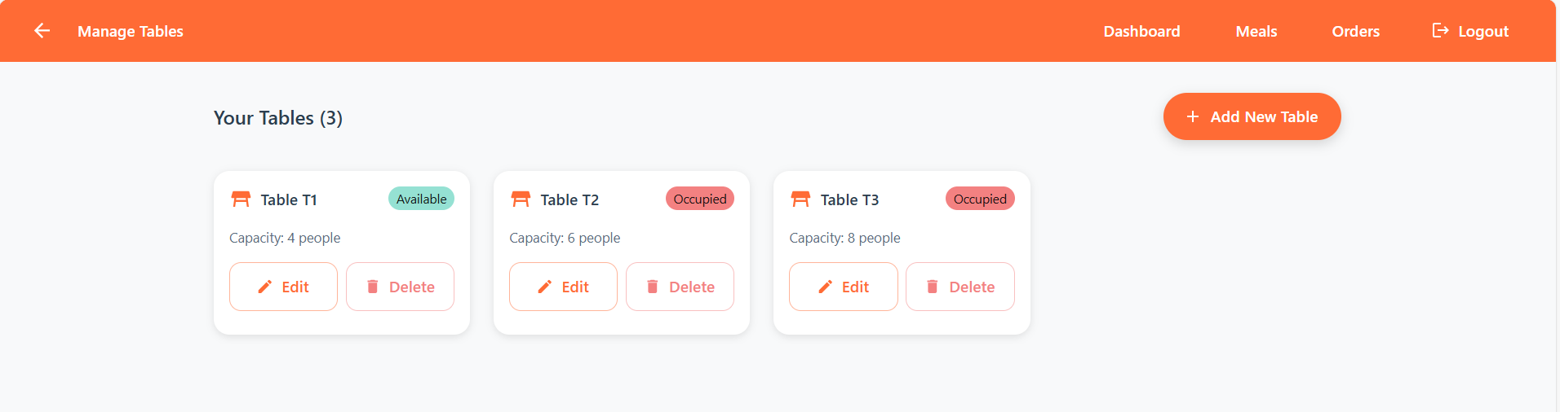
Meal:-
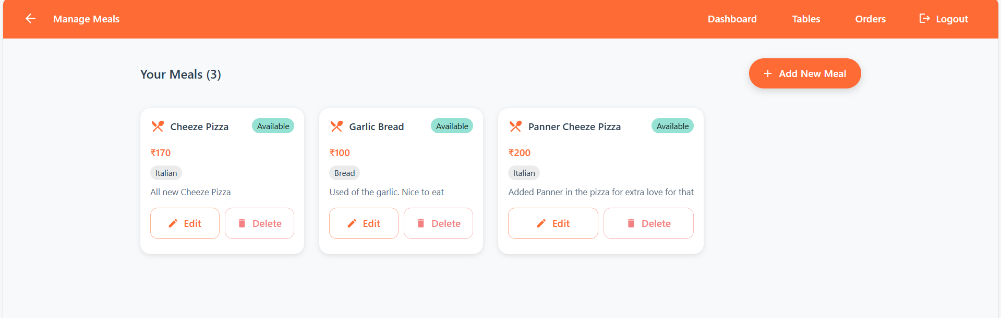

23-12-2025
- Added the functionality of the Forgot Password.
- Based on this reset password will happen on the Email address of that admin/user.
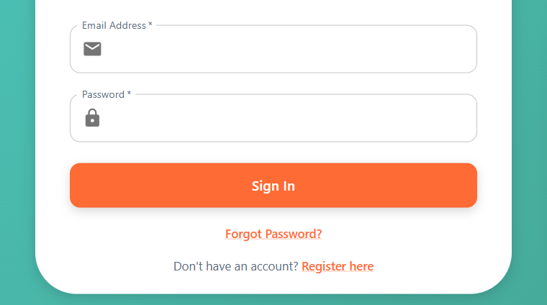
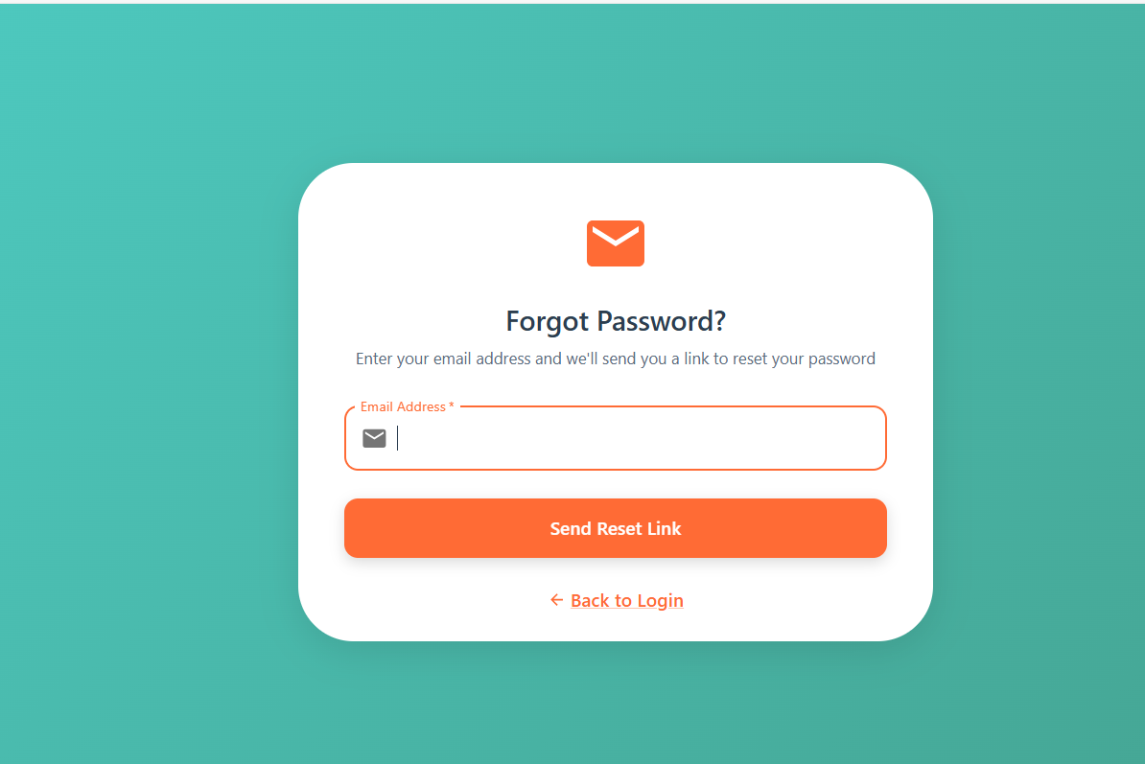

- Added the features of the image in the meals. So that it can be viewed more precise.
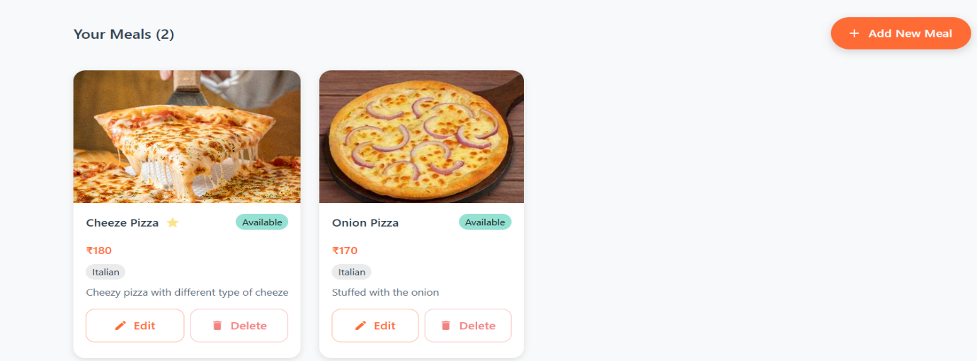
24-12-2025
- In this Added the features of the footer in the restaurant admin side, where it can see the basic details such as name, address contact etc things.
- In this, Location will open in the maps on clicking on that location.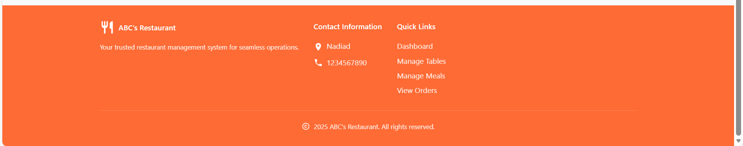
- And some changes also has been done.
26-12-2025
- Added the customer footer in the Customer side. Where they can see the restaurant details etc things.
- And make some of the changes were required in this.

